2010 H2 CHEMISTRY PRELIMINARY EXAMINATION PAPER 3 ANSWERS

1(a)(i)
H⁺(aq)
1 mol dm^{–3}
H₂(g)
at 1 atm,
25 ºC
salt bridge
Pt(s)
Fe³⁺(aq), Fe²⁺(aq)
1 mol dm^{–3}
voltmeter
V
e–

(ii)
Eº_{cell} = Eº(Ag⁺⏐Ag) – Eº(Fe³⁺⏐Fe²⁺) = +0.80 – (+0.77) = +0.03 V > 0
Since Eº_{cell} > 0, reaction is thermodynamically feasible.
Ag⁺ will oxidise Fe²⁺ to Fe³⁺, itself reduced to Ag.
OR Ag⁺(aq) + Fe²⁺(aq) → Ag(s) + Fe³⁺(aq)

The solution changes from pale green to yellow
with deposits of silver metal.

(iii)
4–
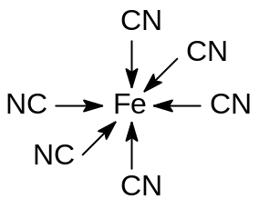

Coordination number of iron is 6.

(iv)
2[Fe(CN)₆]^{4–} + Cl₂ → 2[Fe(CN)₆]^{3–} + 2Cl–

(b)(i)
Pb(s) + PbO₂(s) + 2H₂SO₄(aq) → 2PbSO₄(s) + 2H₂O(l)
Eº_{cell} = 1.47 – (–0.13) = +1.60V
E.m.f of a series of 6 cells = +(6 x 1.60) = +9.60V

(ii)
Both electrodes are coated with the product, PbSO₄(s).
Hence, when an external source of direct current is applied, it will recharge the battery by driving the cell reaction in the reverse direction.

(iii)
Sulfuric acid is consumed during discharging to form solid PbSO₄ and water.
Hence, measuring density of sulfuric acid in the electrolyte provides a quick check on the state of discharge of the battery.
(iv)(I)
During charging, species that can undergo reduction are PbSO₄ and M²⁺.
Since Eº(M²⁺⏐M) is more positive than Eº(PbSO₄⏐Pb),
M²⁺ will be reduced to M preferably.

(II)
During discharging, species that can undergo reduction are PbO₂ and M²⁺.
Since Eº(PbO₂⏐Pb²⁺) is more positive than Eº(M²⁺⏐M), PbO₂ will be reduced to Pb²⁺ preferably.
There is no effect on the discharging process.

(c)(i)
Cobalt(II) salt is behaving as a catalyst.

(ii)
Any three of the following.
The rate of reaction between sodium tartrate and hydrogen peroxide in the absence of a catalyst is slow. Hence, only a slow stream of carbon dioxide is produced.
When cobalt(II) salt is added as catalyst, rate of reaction increases rapidly. Hence a vigorous effervescence of carbon dioxide occurs.
Cobalt(II) salt changes from pink to green colour which is the intermediate formed in the catalysed reaction.
When the reaction stops, pink colour is restored. Cobalt(II) salt is regenerated. Hence cobalt (II) serves as a catalyst.

2(a)(i)
P_{CO} = 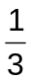 x 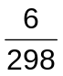 x 500
= 3.36 atm

(ii)
K_{p} = 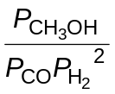

(iii)
P_{H2} = 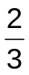 x x 500 (ecf)
= 6.71 atm

 | CO(g) + | 2H₂(g) | ⇌ | CH₃OH(g)
Initial / atm | 3.36 | 6.71 |  | 0
Change / atm | –3.2 | –6.4 |  | 3.2
Equilibrium / atm | 0.16 | 0.31 |  | 3.2

(iv)
K_{p} = 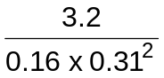 (ecf)
= 208 atm^{–2} (ecf)

(b)(i)
a is dependent on the strength of the attractive forces between molecules while
b is dependent on the volume of the molecules.

(ii)
Attractive forces slow down the movement of a molecule approaching the wall of the container.
This causes the actual pressure to be lower than that of an ideal gas.
Hence, the term is added to P.
The volume of the molecules causes the free space within which molecules
can move to be less than the entire volume of the container.
Hence, the b term is subtracted from V.

(iii)
Both helium and carbon dioxide are made up of non–polar molecules held by dispersion forces.
Dispersion forces in CO₂ are stronger due to the higher number of electrons present. Hence, CO₂ has a higher value of a than He.
Ammonia molecules are held by hydrogen bonding
which is stronger than dispersion forces. Hence, ammonia has the highest a value.

(c)(i)
A buffer solution is one that resists changes in pH
when a small amount of acid or base is added.

(ii)
7.90 × 10⁻⁷ = [H⁺][HCO₃⁻] / [H₂CO₃]
= 10^{−7.4} [HCO₃⁻] / [H₂CO₃]

[HCO₃⁻] / [H₂CO₃] = 19.8

(iii)
HCO₃⁻ + RCO₂H → H₂CO₃ + RCO₂⁻

(iv)
As more H₂CO₃ is formed,
position of equilibrium I shifts left.
This increases [CO₂(aq)]
and in turn causes the position of equilibrium III to shift right, i.e. breathing rate increases.

(v)
Let the volume of NaOH added be V cm³.
Initial moles of H₂CO₃ = 0.20 x 25.0 x 10^{–3}
= 5.0 x 10^{–3} mol

Moles of H₂CO₃ left after neutralisation = 5.0 x 10^{–3} – 0.30 V x 10^{–3}
= 0.005 – 3 x 10^{–4} V mol

Moles of HCO₃– formed = moles of NaOH used = 3 x 10^{–4} V mol
3 x 10^{–4} V / [0.005 – 3 x 10^{–4} V] = 19.8 (ecf from (c)(ii))
V = 15.9 cm³

3(a)
B is a carboxylic acid.
B is CH₃CO₂H.
B undergoes reduction with LiAlH₄ in dry ether
to give an alcohol, D.

D undergoes oxidation with alkaline I₂(aq)
to give a yellow ppt of CHI₃.
D contains CH₃CH(OH)– group only.
D is CH₃CH₂OH.

E undergoes oxidative cleavage to give B, CH₃CO₂H, and propanic acid, CH₃CH₂CO₂H.
E is CH₃CH=CHCH₂CH₃.

C undergoes neutralisation with NaOH(aq) to form an amine.
Amine is CH₃CH₂CH(NH₂)CH₂CH₃.
An elimination in either way will yield the same alkene, E.
C is CH₃CH₂CH(NH₃⁺)CH₂CH₃ Cl–.
A is CH₃CH₂CH(NH₃⁺)CH₂CH₃ (CH₃CO₂–).

(I)
CH₃CH₂OH + 4I₂ + 6OH– → HCO₂– + CHI₃ + 5I– + 5H₂O

(I)
CH₃CH=CHCH₂CH₃+ 4[O] → CH₃CO₂H + CH₃CH₂CO₂H
[12.5, max 10]

(b)(i)
rate = k [OH–] [NR₄⁺]
Units of k: mol^{–1} dm³ s^{–1}

(ii)
[OH–]
time
x –
x/2 –
x/4 –
t_{1/2}
t_{1/2}

correct curve
show 2 constant t_{1/2}

(iii)(I)
Half–life remains unchanged.

(II)
Half–life is halved.

(iv)
No. of particles
Energy
E_{a}

T₁
T₂ > T₁

Both curves sketched correctly.
As temperature increases, molecules possess greater kinetic energy.
Hence, the number of molecules with energy greater or equal to activation energy is larger
as shown by the two shaded areas in the diagram above.
This results in higher frequency of effective collisions and hence higher rate of reaction.

(c)
CH₃CH₂CH=CHCH₃ is more stable than CH₃CH₂CH₂CH=CH₂ due to greater number of alkyl groups.
Higher E_{a} for pathway leading to production of less CH₃CH₂CH=CHCH₃.

4(a)(i)
 | S₂O₃^{2–} | X– | SO₄^{2–}
No. of moles | 0.0125 | 0.0500 x 2  = 0.100 | 0.0125 x 2  = 0.0250
Mole ratio | 1 | 8 | 2

4X₂ + S₂O₃^{2–} + 5H₂O → 2SO₄^{2–} + 8X– + 10H⁺

(ii)
Y₂ + 2S₂O₃^{2–} → 2Y– + S₄O₆^{2–}

(iii)
Change in oxidation number of S in (a)(i) (from +2 to +6) is greater than in (a)(ii) (from +2 to +2½).
X₂ is a stronger oxidising agent than Y₂.

(b)(i)
Add hot aqueous sodium hydroxide to aqueous chlorine

(ii)
Ethanedioic acid is a reducing agent in the reaction.
Oxidation state of chlorine decreased from +5 in ClO₃– to +4 in ClO₂.

(c)(I)
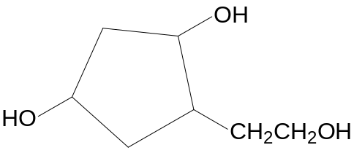
Na⁺ –O₂CCH₂CH=C(CH₃)₂

(II)
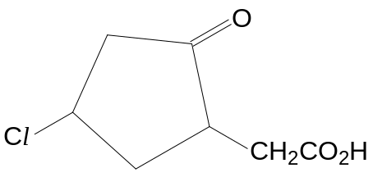

CH₂(CO₂H)₂
(CH₃)₂CO

(d)(i)
Mechanism: electrophilic substitution

CH₃COCl + AlCl₃ → CH₃CO⁺ + AlCl₄–
electrophile

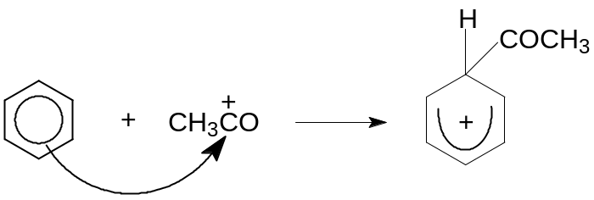
resonance–stabilised
carbocation intermediate

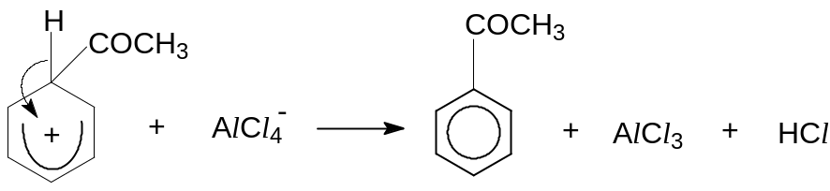

AlCl₃ catalyst is regenerated.

(ii)(I)
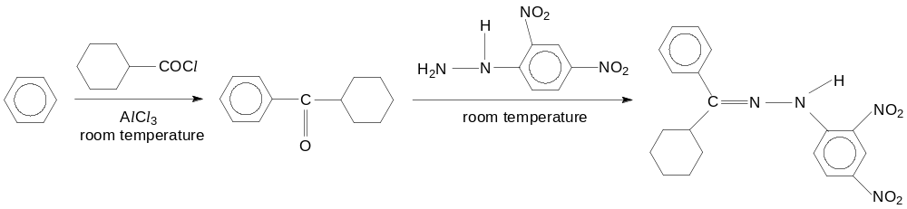

(II)
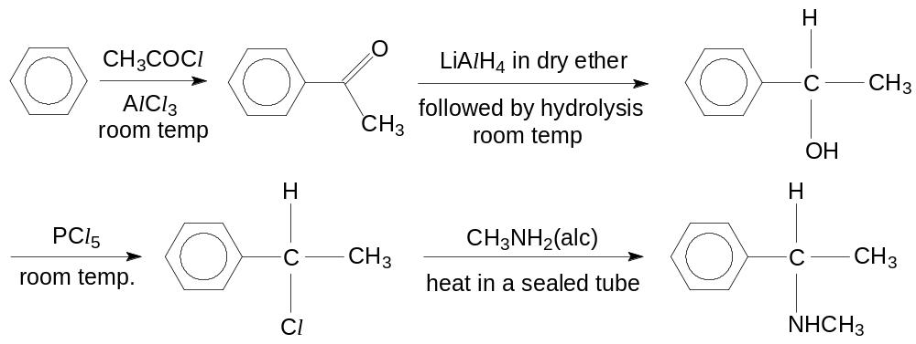

5(a)(i)
Isoelectric point refers to the pH at which all amino acids exist as zwitterions, hence there will be no migration of amino acids when placed in an electric field.

Zwitterion is a dipolar ion with a positive charge and a negative charge, hence it is electrically neutral such as amino acids, ⁺NH₃–CHR–COO–.

(ii)
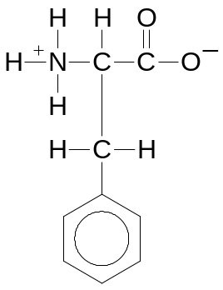

(iii)
C₆H₅CH₂CH(NH₂)CO₂H + HCl → C₆H₅CH₂CH(CO₂H)NH₃⁺ Cl–
C₆H₅CH₂CH(NH₂)CO₂H + NaOH → C₆H₅CH₂CH(NH₂)CO₂– Na⁺ + H₂O
[Can express in zwitterionic forms too.]

(iv)
Phenylalanine has a giant ionic structure consisting of dipolar ions held by strong ionic bonds which need a lot of energy to overcome. Hence, it has a high melting point and exists as a solid at room temperature.

Being ionic, phenylalanine can attract polar water molecules by forming ion–dipole bonds. The energy liberated from these interactions is sufficient to overcome the ionic bonds between phenylalanine and the hydrogen bonds between water molecules, enabling it to dissolve in water.

(b)
In fibrous proteins, the polypeptides are arranged in a long and elongated structure with alkyl groups pointing towards the external surroundings. The hydrophobic alkyl groups will repel water molecules causing the proteins to be insoluble in water.

In globular proteins, the polypeptides are folded into a compact rounded structure with hydrophobic alkyl groups located inside the structure, away from the aqueous surroundings. The hydrophilic alkyl groups are located on the surface of the protein structure, and they can attract water molecules enabling globular proteins to dissolve in water.

(c)(i)
–CONH– + H₂O → –CO₂H + –NH₂

(ii)
Pepsin undergoes denaturation when boiled.
Boiling provides heat energy that can disrupt the bonds and forces of
attractions between R groups responsible for stabilising the tertiary structure and the hydrogen bonds between the peptide linkages responsible for stabilizing the secondary structures of pepsin,
causing the polypeptide chains to unfold/uncoil/unravel.
As a result, pepsin is unable to perform its catalytic function.

(d)(i)
Step I: Nucleophilic substitution
concentrated solution of CH₃NH₂, room temperature

Step II: Reduction
H₂, Pt at room temperature or H₂, Ni at 140 ºC or LiAlH₄ in dry ether, room temperature

Step III: Nucleophilic substitution
CH₃Cl, heat

(ii)
Add AgNO₃(aq) at room temperature to compound A and compound B separately.
Only A will give a white precipitate of AgCl.

